- \Operation\Tube print registration\ Tube print registration
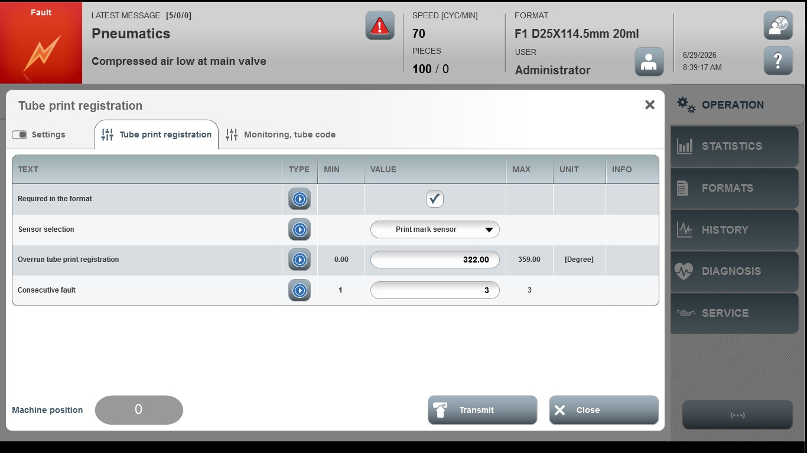
Acceptance criterion | Limits | Pass / Fail: Dev-No. | Date | Initials
Screen matches screenshot | N / A
Overrun tube print registration | 0.00 … 359.00
Consecutive fault | 1 … 3

